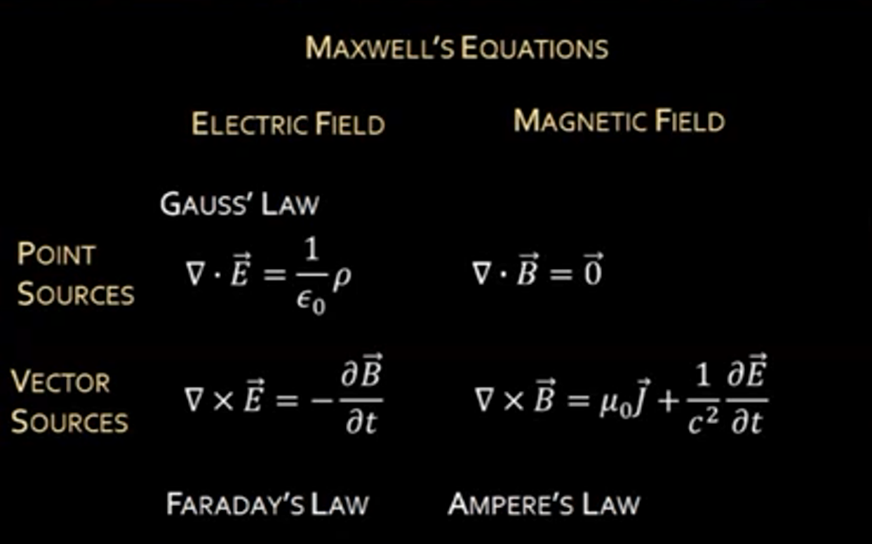
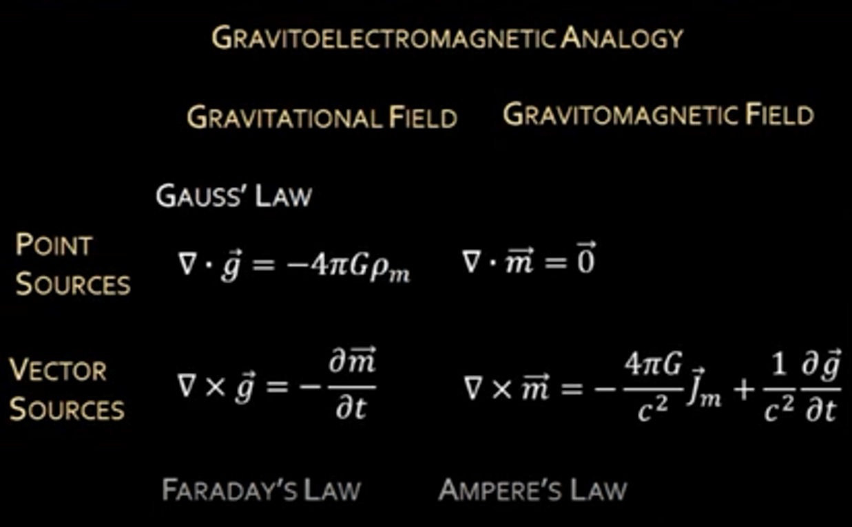
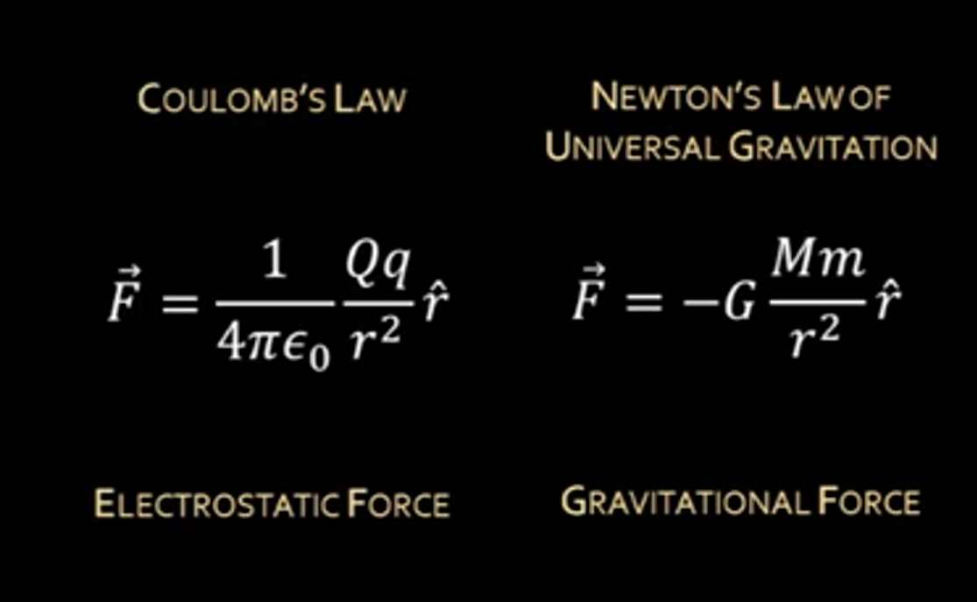

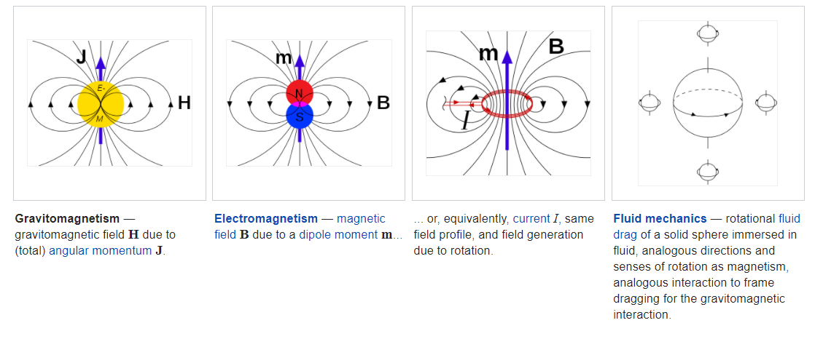

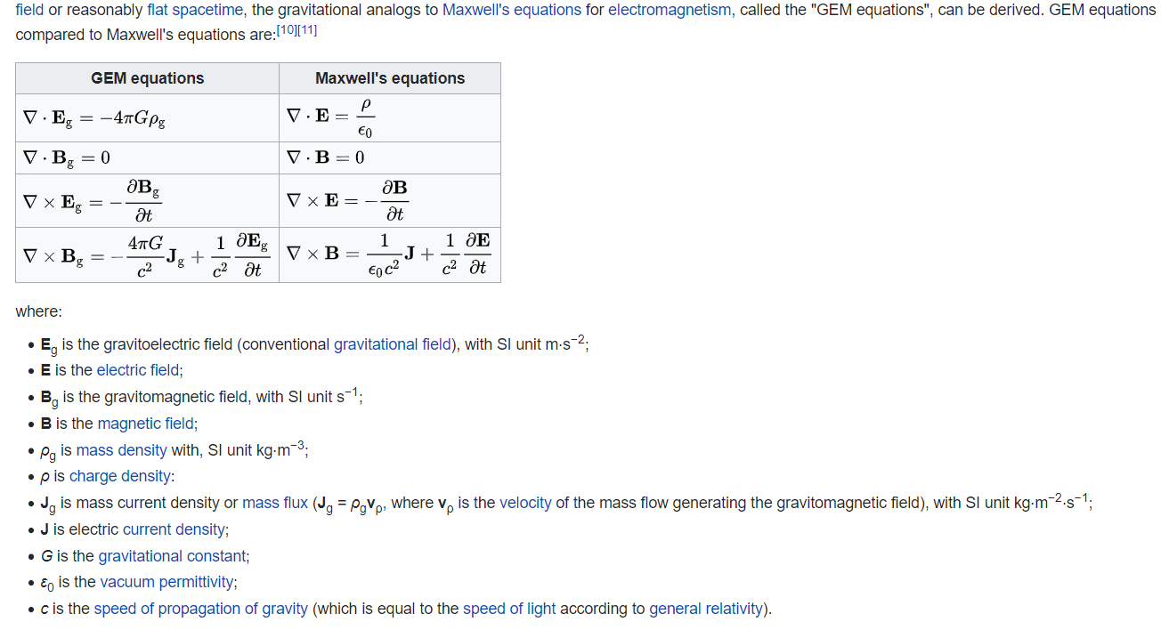

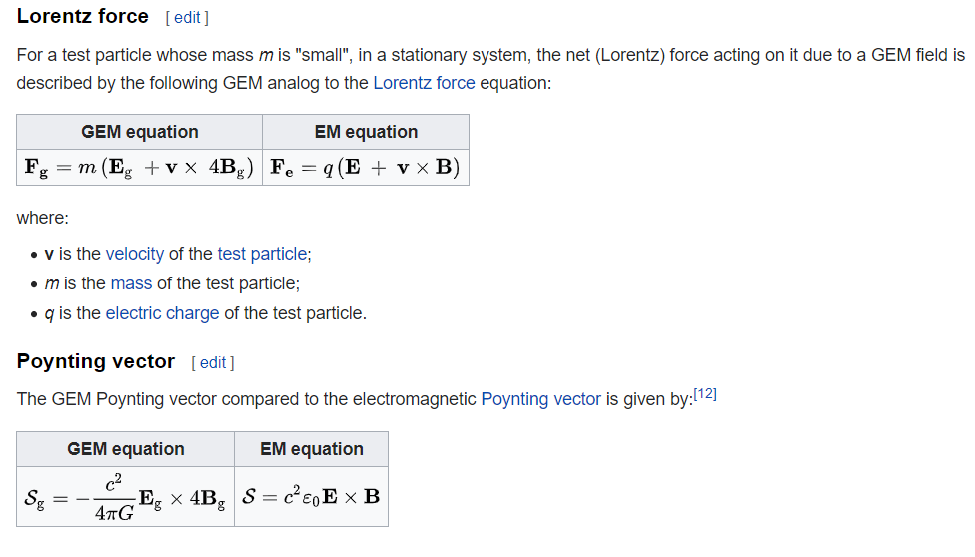

Scaling of fields[edit]
The literature does not adopt a consistent scaling for the gravitoelectric and gravitomagnetic fields, making comparison tricky. For example, to obtain agreement with Mashhoon's writings, all instances of Bg in the GEM equations must be multiplied by −12 c and Eg by −1. These factors variously modify the analogues of the equations for the Lorentz force. No scaling choice allows all the GEM and EM equations to be perfectly analogous. The discrepancy in the factors arises because the source of the gravitational field is the second order stress–energy tensor, as opposed to the source of the electromagnetic field being the first order four-current tensor. This difference becomes clearer when one compares non-invariance of relativistic mass to electric charge invariance. This can be traced back to the spin-2 character of the gravitational field, in contrast to the electromagnetism being a spin-1 field.[13] (See relativistic wave equations for more on "spin-1" and "spin-2" fields).
/

Electromagnetism and Maxwell’s Equations:
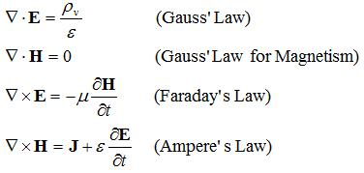
To properly understand some of the more technical aspects of not just this chapter but also the following chapters it is necessary to first start with a basic understanding of the equations that define the interplay between electricity and magnetism, later we will add gravity in the gravito-electromagnetism equations. There are plenty of places to turn to for a further elucidation of the Maxwell equations and their history. Some conspiratorial authors allege that the equations have a hidden component or that they are incomplete, etc. The reality is that our understanding of things is always developing and rather then having some miraculous hidden science, what is really hidden is merely a question of specific techniques not fundamental principles or new principles of Physics, for instance later we will learn of the ‘microlepton’ theory regarding remote influencing, which was the real scientific physics of the Ahronov-Bohm Effect, though it has been paraded around as some new or hidden theory of science by western new-age pseudo-scientists, which to a skeptical observer again asks if this is obfuscation by intent by those keeping techniques secret for national security. The confusion came in that the original Maxwell equations were more then the paired down 4, creating confusion with some that somehow there was hidden equations with the ‘real truth’. The real truth is we are discovering things about things we knew long ago on a daily basis rather then having a hidden aspect of established science. The reason there are 4 equations today is that you can encapsulate the entirety of electromagnetism in these 4 equations, plust a Lorentz Lemma, which is used to measure force from the equations. These are known as the Heaveside Vector equations, whereas there is also a quaternion based potential equations we shall encounter later.

Maxwell Equations for Electro-Magnetism (EM)

Maxwell’s equations as we understand them today were abridged by Heaveside. The original Maxwell equations comprised dozens of equations, which were simplified by Heaveside to the four main equations below. As far as the potential energy vectors of Ahronov-Bohm effect, these equations were first hinted at in the work of Whittaker in 1904, a one-time astrophysics teacher at the Observatory in Dublin, Ireland.
Here I list the Maxwell Equations for reference. These equations are taken from Gravitational Physicist Raymond Chiao of the University of California at Merced, I reference his work below for the Gravitational versions of these equations as well
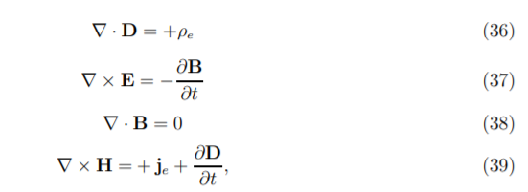
where ρ_{e} is the electrical free charge density (here, the charge density of Cooper pairs), and j_{e} is the electrical current density (due to Cooper pairs), D is the displacement field, E is the electric field, B is the magnetic induction field, and H is the magnetic field intensity.

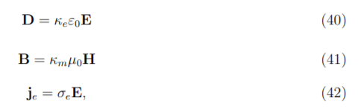
where κ_{e} is the dielectric constant of the medium, κ_{m} is its relative permeability, and σ_{e} is its electrical conductivity (Chiao et al, 2002)

For clarification the field we are mainly interested in is the B (magnetic) Field, which in the quaternion version of the Maxwell Equations of Whittaker is the B (magnetic) Field, which in the quaternion is the trinary (x,y,z) magnetic vector A usually annotated (A, Φ) for both the scalar part and the vector part.

Ahronov Bohm Effect

In a 1959 paper, Y. Aharonov and D. Bohm contrary to the conclusions of classical mechanics, the electromagnetic 4-potential, the motion of an electron beam, even in regions where the electromagnetic field vanishes can still affect a particle. Ahronov-Bohm takes hold at boundaries and in macrostructures in phase shifts of matter, “Attributing the Aharonov-Bohm effect to the four-potential A is possible only where the EM field vanishes.” (Friedman et al, 2014) The application of the A Vector Potential is based on the work of Whittaker in 1904. As explained by Israeli Mathematician Friedman:

The Aharonov-Bohm effect is traditionally attributed to the affect of the electromagnetic 4-potential A, even in regions where both the electric field E and the magnetic field B are zero. We argue that the quantity measured by AB experiments may be the difference in values of a multiple-valued complex function, which we call a pre-potential [Persinger’s Second Derivative? See below]. The pre-potential is a combination of the two scalar potential functions introduced by E. T. Whittaker. We show that any electromagnetic field can be described by such pre-potential, and give an explicit expression for the electromagnetic field tensor through this potential. (Friedman et al, 2014)

Another important understanding to have of the A Vector is that it is applicable to quantum physics not classical physics as indicated by Waechter:

In contrast to classical mechanics, where the equation(s) of motion contain only the electric and magnetic field, in quantum mechanics the Schrödinger equation explicitly contains the electromagnetic potentials. This fact was known since the beginning of quantum mechanics, but it wasn’t until the publishing of the paper Significance of Electromagnetic Potentials in the Quantum Theory [7] by Y. Aharonov and D. Bohm in 1959, that the consequences of this fact received serious attention. (Waechter, 2018)

An electromagnetic four-potential is a relativistic vector function from which the electromagnetic field can be derived. It combines both an electric scalar potential and a magnetic vector potential into a single four-vector.
As measured in a given frame of reference, and for a given gauge, the first component of the electromagnetic four-potential is conventionally taken to be the electric scalar potential, and the other three components make up the magnetic vector potential. While both the scalar and vector potential depend upon the frame, the electromagnetic four-potential is Lorentz covariant.
Like other potentials, many different electromagnetic four-potentials correspond to the same electromagnetic field, depending upon the choice of gauge.
The magnetic vector potential A is a vector field, defined along with the electric potential ϕ (a scalar field) by the equations:
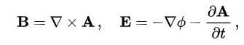
where B is the magnetic field and E is the electric field.

The A-B Effect involves using potential energies at boundaries of EM Fields where the field disappears but not potential energies or what I would call information. In the toroidal and solenoid experiments with A-B Generators of Pesinger’s Group they work changing phase shifts:

The phase shift of the Aharanov-Bohm effect can be described as:
Δθ=qVt ħ-1 (1),
where q is the unit charge, V is the voltage, t is the time or duration within the voltage field and ħ is the modified Planck’s constant.” (Koren, 2016) More specifically the involvement of an Aharanov-Bohm effect indicates that for phase-modulation or phase shift to occur the average change in voltage must be near the peaks of capacity but not at the peaks of capacity. Consequently forcing the systems to its limits or maximum boundaries (-5 to +5 V), in addition to distorting the signal, would be above the narrow band pass. This has been observed in our systems. Values below the value would not be sufficient to elicit the effect. Because our signals are constructed from a series of numbers (integers) ranging from 0 through 256 (-5 to +5 V) and pass through the critical zone, perhaps the efficacy of our patterns might be re-evaluated with respect to what proportion of “time” or passes occur within the 4.1 to 4.3 V band. This could be considered a metaphor for the duration within the voltage field.” (Koren, 2016)

.

Gravitational Maxwell Equations

The Soviet researchers learned that there is a conversion between Electromagnetic Waves and Gravitational Waves. Which explains the Soviets focus on Gravitational Wave based non-local cybernetic experiments as early as 1967 (McCarron, 2021, Ch. 6 ‘Physics of Neuroweapons’). A Russian researcher, V. Samokhvalov, continuing on the earlier Soviet research in this area, explains the subtle energies which could be overlooked, he comments:

According to Einstein’s general theory of relativity, the rotating mass field differs from non-rotating mass field by additional, so-called, gravimagnetic forces , which affect rotating objects . Taking this fact into consideration, it is assumed that gravimagnetic forces act only if they are close to large masses or in presence of masses moving at relativistic speed, and they do not exhibit themselves in nature because of their extremely small values. However, many researchers in their works mentioned facts, which showed significant non-electromagnetic interaction of small objects, rotating at low speeds, with each other and with the objects, surrounding them.

One of the first evidences of such kind was the experiments of Professor N.P. Myshkin, which were carried out at the beginning of the XX century. The effect of change in weight of rotating objects (gyroscopes) and their non-electromagnetic interaction with other objects are described in works by N.A. Kozyrev, V.V. Roshin and S.M. Godin, S.V. Plotnikov, etc. The experimental research...also showed that in nature there is a significant value contactless interaction of rotating small masses and their force effect on closely located objects (masses) at relatively small rotary and linear speeds of rotation. The value of occurring mass-dynamic forces is by 20 orders more than the value of gravimagnetic forces, which act in this case according to general theory of relativity.[see Persinger observation of 20x greater entanglement reactions in his experiments of non-local entanglement]

Experimentally determined non-electromagnetic interaction was called mass-dynamic interaction, because it is determined by dynamic mass rotation, having a variable quadrupole [see Einstein’s Gravitational Quadropole equation below] moment. The research, which was carried out, showed non-electromagnetic nature of force interaction, i.e. independence of interaction force effects from electrical conductivity of disc materials and dependence of force interaction value on their rotation frequency.
(Samokhvalov, 2016)

The deniers of the scientific reality of this technology, which seems to be an information operation aimed at keeping state-secrets secret, have claimed that this is an EM conductive or thermal effect, this is not what the researchers are claiming, they are claiming that there is a potential EM non-thermal effect, A-B Effect, and that is the basis of the A-B Generators. This is also related to the argument against Thought-Injection or QSK that the magnitudes, here talking about magnetic fields of 1-5μT, are too small in terms of electric conduction, which we see below is not based on experimental findings. .

There is another A-B Effect that is not EM based. The equivalent in Gravitational Theory, according to many researchers, including R. Chiao, the gravitational equivalent of the Gravitational Ahronov-Bohm effect. So that one does not as seen need to use Electric force in entanglement experiments but rather magnetic potentials can accomplish what force can. Chiao has written of the conversion from Maxwell Equations to Gravitomagnetic Maxwell Equations.

“The gravitoelectric field E_{G}, which is identical to the local acceleration due to gravity g, is analogous to the electric field E, and the gravitomagnetic field B_{G}, which is identical to the Lense-Thirring field (Poynting Vector of Magnetic flux), is analogous to the magnetic field B; they are related to the vector potential h in the radiation gauge as follows:
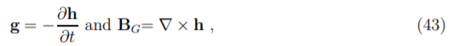
which correspond to the electromagnetic relations in the radiation gauge
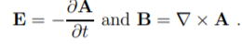
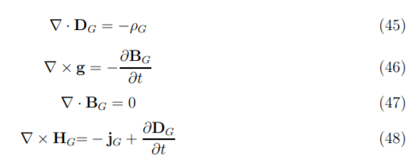
(Chiao et al, 2002)

where ρG is the density of local rest mass in the local rest frame of the matter, and jG is the local rest-mass current density in this frame (in the case of classical matter, jG = ρGv, where v is the coordinate three-velocity of the local rest mass; in the quantum case, see Eq. (64)). Here H_{G} is the gravitomagnetic field intensity, and D_{G} is the gravitodisplacement field. Since the forms of these equations are identical to those of Maxwell’s equations, the same boundary conditions follow from them, and therefore the same solutions for electromagnetic problems carry over formally to the gravitational ones.” (Chiao et al, 2002)

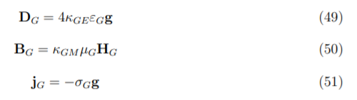
where εG is the gravitoelectric permittivity of free space given by Eq. (35), µG is the gravitomagnetic permeability of free space given by Eq. (32), κGE is the gravitoelectric dielectric constant of a medium, κGM is its gravitomagnetic relative permeability, and σG is the gravitational analog of the electrical conductivity of the medium, whose magnitude is inversely proportional to its viscosity (Chiao, 2002)

Viscosity and brain structure are reviewed in McCarron 2021 Ch. 8

So it is important to understand there is a gravitational correlate to EM, as shall be pointed out later these potentials exist not in classical scale but quantum scale. It is worthwhile to point out there is a high frequency gravitational wave based equivalent to this type of remote sensing as adapted see Baker-Li HFGW Military Applications in McCarron 2021 Ch. 6 ‘Physics of Neuroweapons’.

Einstein’s Quadropole Equation:
To measure the strength of a Gravitational Wave due to the change of masses the following equations were formulated.

Because of symmetry, the quadropole moment (of Einstein’s quadropole-approximation equation) can be related to a principal moment of inertia, I, of a mass system and can be approximated by
In which -dE/dt is the generated power output of the GW source, P is in watts, c is the
speed of light, G is the universal constant of gravitation, and d³I/dt³ is the third time
derivative of the moment of inertia of the mass system. The GW power is usually quite
small because of the small coefficient multiplier. (Baker, 2010, 20)

The GW frequency is 2ω or twice the orbital frequency ω. That is, for ever period of an electron the graviton is 2x, twice the frequency of the electron. Following for a one-meter long rod spun so fast as to nearly break apart due to centrifugal force, the radiated GW power is only 10⁻³⁷ watts. Through the coupling of gravity to electromagnetism and electromagnetisms relation to photons we see a graviton-photon-electron continuity where gravitons can become photons become electrons and reverse, which is important in entanglement which is a product of angular momentum.
All this serves to come together to explain how waves in general and specifically radio waves, microwaves (mm), light waves (nm), are all comprised of electromagnetism, that is force (electricity, E Vector) and structure (magnetism, B Vector). Which leads to the discussion of the use of Radar and it’s relationship to Neuroweapons.

Radar and Neuroweapons
My first experience with radar was as a radar opertor in the US Navy. Watching the sweeping green line making its centrifical rounds of any contacts on the green tinted screen. Radar is a detection system that uses radio waves to determine the range, angle, or velocity of objects. It can be used to detect aircraft, ships, spacecraft, guided missiles, motor vehicles, weather formations, and terrain. A radar system consists of a transmitter producing electromagnetic waves in the radio or microwaves domain, a transmitting antenna, a receiving antenna (often the same antenna is used for transmitting and receiving) and a receiver and processor to determine properties of the object(s). Radio waves (pulsed or continuous) from the transmitter reflect off the object and return to the receiver, giving information about the object's location and speed. Radar is a direct outcome of the British need to detect incoming Nazi German aircraft, and again we see the relationship of technical advance to warfare.

As early as 1886, German physicist Heinrich Hertz showed that radio waves could be reflected from solid objects. In 1895, Alexander Popov, a physics instructor at the Imperial Russian Navy school in Kronstadt, developed an apparatus using a coherer tube for detecting distant lightning strikes. The next year, he added a spark-gap transmitter. In 1897, while testing this equipment for communicating between two ships in the Baltic Sea, he took note of an interference beat caused by the passage of a third vessel. In his report, Popov wrote that this phenomenon might be used for detecting objects, but he did nothing more with this observation.
The German inventor Christian Hülsmeyer was the first to use radio waves to detect "the presence of distant metallic objects". In 1904, he demonstrated the feasibility of detecting a ship in dense fog, but not its distance from the transmitter. He obtained a patent for his detection device in April 1904 and later a patent for a related amendment for estimating the distance to the ship. He also obtained a British patent on September 23, 1904 for a full radar system, that he called a telemobiloscope. It operated on a 50 cm wavelength and the pulsed radar signal was created via a spark-gap. His system already used the classic antenna setup of horn antenna with parabolic reflector and was presented to German military officials in practical tests in Cologne and Rotterdam harbour but was rejected.
In 1915, Robert Watson-Watt used radio technology to provide advance warning to airmen and during the 1920s went on to lead the U.K. research establishment to make many advances using radio techniques, including the probing of the ionosphere and the detection of lightning at long distances. Through his lightning experiments, Watson-Watt became an expert on the use of radio direction finding before turning his inquiry to shortwave transmission. Requiring a suitable receiver for such studies, he told the "new boy" Arnold Frederic Wilkins to conduct an extensive review of available shortwave units. Wilkins would select a General Post Office model after noting its manual's description of a "fading" effect (the common term for interference at the time) when aircraft flew overhead.
Across the Atlantic in 1922, after placing a transmitter and receiver on opposite sides of the Potomac River, U.S. Navy researchers A. Hoyt Taylor and Leo C. Young discovered that ships passing through the beam path caused the received signal to fade in and out. Taylor submitted a report, suggesting that this phenomenon might be used to detect the presence of ships in low visibility, but the Navy did not immediately continue the work. Eight years later, Lawrence A. Hyland at the Naval Research Laboratory (NRL) observed similar fading effects from passing aircraft; this revelation led to a patent application as well as a proposal for further intensive research on radio-echo signals from moving targets to take place at NRL, where Taylor and Young were based at the time.Just before World War II
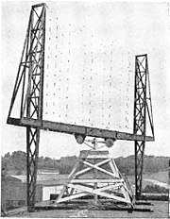
Experimental radar antenna, US Naval Research Laboratory, Anacostia, D. C., late 1930s
Before the Second World War, researchers in the United Kingdom, France, Germany, Italy, Japan, the Netherlands, the Soviet Union, and the United States, independently and in great secrecy, developed technologies that led to the modern version of radar. Australia, Canada, New Zealand, and South Africa followed prewar Great Britain's radar development, and Hungary generated its radar technology during the war.
In France in 1934, following systematic studies on the split-anode magnetron, the research branch of the Compagnie Générale de Télégraphie Sans Fil (CSF) headed by Maurice Ponte with Henri Gutton, Sylvain Berline and M. Hugon, began developing an obstacle-locating radio apparatus, aspects of which were installed on the ocean liner Normandie in 1935.
During the same period, Soviet military engineer P.K. Oshchepkov, in collaboration with Leningrad Electrophysical Institute, produced an experimental apparatus, RAPID, capable of detecting an aircraft within 3 km of a receiver. The Soviets produced their first mass production radars RUS-1 and RUS-2 Redut in 1939 but further development was slowed following the arrest of Oshchepkov and his subsequent gulag sentence. In total, only 607 Redut stations were produced during the war. The first Russian airborne radar, Gneiss-2, entered into service in June 1943 on Pe-2 dive bombers. More than 230 Gneiss-2 stations were produced by the end of 1944. The French and Soviet systems, however, featured continuous-wave operation that did not provide the full performance ultimately synonymous with modern radar systems.
Full radar evolved as a pulsed system, and the first such elementary apparatus was demonstrated in December 1934 by the American Robert M. Page, working at the Naval Research Laboratory. The following year, the United States Army successfully tested a primitive surface-to-surface radar to aim coastal battery searchlights at night. This design was followed by a pulsed system demonstrated in May 1935 by Rudolf Kühnhold and the firm GEMA [de] in Germany and then another in June 1935 by an Air Ministry team led by Robert Watson-Watt in Great Britain.
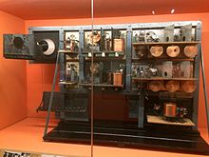
The first workable unit built by Robert Watson-Watt and his team
In 1935, Watson-Watt was asked to judge recent reports of a German radio-based death ray and turned the request over to Wilkins. Wilkins returned a set of calculations demonstrating the system was basically impossible. When Watson-Watt then asked what such a system might do, Wilkins recalled the earlier report about aircraft causing radio interference. This revelation led to the Daventry Experiment of 26 February 1935, using a powerful BBC shortwave transmitter as the source and their GPO receiver setup in a field while a bomber flew around the site. When the plane was clearly detected, Hugh Dowding, the Air Member for Supply and Research was very impressed with their system's potential and funds were immediately provided for further operational development. Watson-Watt's team patented the device in GB593017.
Development of radar greatly expanded on 1 September 1936 when Watson-Watt became Superintendent of a new establishment under the British Air Ministry, Bawdsey Research Station located in Bawdsey Manor, near Felixstowe, Suffolk. Work there resulted in the design and installation of aircraft detection and tracking stations called "Chain Home" along the East and South coasts of England in time for the outbreak of World War II in 1939. This system provided the vital advance information that helped the Royal Air Force win the Battle of Britain; without it, significant numbers of fighter aircraft, which Great Britain did not have available, would always need to be in the air to respond quickly. If enemy aircraft detection relied solely on the observations of ground-based individuals, Great Britain may have lost the Battle of Britain. Also vital was the "Dowding system" of reporting and coordination to provide the best use of radar information during the tests of early radar deployment during 1936 and 1937.
Given all required funding and development support, the team produced working radar systems in 1935 and began deployment. By 1936, the first five Chain Home (CH) systems were operational and by 1940 stretched across the entire UK including Northern Ireland. Even by standards of the era, CH was crude; instead of broadcasting and receiving from an aimed antenna, CH broadcast a signal floodlighting the entire area in front of it, and then used one of Watson-Watt's own radio direction finders to determine the direction of the returned echoes. This fact meant CH transmitters had to be much more powerful and have better antennas than competing systems but allowed its rapid introduction using existing technologies.
A key development was the cavity magnetron in the UK, which allowed the creation of relatively small systems with sub-meter resolution. Britain shared the technology with the U.S. during the 1940 Tizard Mission.
In April 1940, Popular Science showed an example of a radar unit using the Watson-Watt patent in an article on air defence.[ Also, in late 1941 Popular Mechanics had an article in which a U.S. scientist speculated about the British early warning system on the English east coast and came close to what it was and how it worked. Watson-Watt was sent to the U.S. in 1941 to advise on air defense after Japan's attack on Pearl Harbor. Alfred Lee Loomis organized the secret MIT Radiation Laboratory at Massachusetts Institute of Technology, Cambridge, Massachusetts which developed microwave radar technology in the years 1941–45. Later, in 1943, Page greatly improved radar with the monopulse technique that was used for many years in most radar applications.
The war precipitated research to find better resolution, more portability, and more features for radar, including complementary navigation systems like Oboe used by the RAF's Pathfinder.

Illumination
Radar relies on its own transmissions rather than light from the Sun or the Moon, or from electromagnetic waves emitted by the target objects themselves, such as infrared radiation (heat). This process of directing artificial radio waves towards objects is called illumination, although radio waves are invisible to the human eye as well as optical cameras.

The klystron was the first significantly powerful source of radio waves in the microwave range; before its invention the only sources were the Barkhausen-Kurz tube and split anode magnetron, which were limited to very low power. It was invented by the brothers Russell and Sigurd Varian at Stanford University. Their prototype was completed and demonstrated successfully on August 30, 1937. Upon publication in 1939, news of the klystron immediately influenced the work of US and UK researchers working on radar equipment. The Varians went on to found Varian Associates to commercialize the technology (for example, to make small linear accelerators to generate photons for external beam radiation therapy). Their work was preceded by the description of velocity modulation by A. Arsenjewa-Heil and Oskar Heil (wife and husband) in 1935, though the Varians were probably unaware of the Heils' work.[6]
The work of physicist W.W. Hansen was instrumental in the development of the klystron and was cited by the Varian brothers in their 1939 paper. His resonator analysis, which dealt with the problem of accelerating electrons toward a target, could be used just as well to decelerate electrons (i.e., transfer their kinetic energy to RF energy in a resonator). During the second World War, Hansen lectured at the MIT Radiation labs two days a week, commuting to Boston from Sperry Gyroscope Company on Long Island. His resonator was called a "rhumbatron" by the Varian brothers. Hansen died of beryllium disease in 1949 as a result of exposure to beryllium oxide (BeO).
During the Second World War, the Axis powers relied mostly on (then low-powered and long wavelength) klystron technology for their radar system microwave generation, while the Allies used the far more powerful but frequency-drifting technology of the cavity magnetron for much shorter-wavelength one centimeter microwave generation. Klystron tube technologies for very high-power applications, such as synchrotrons and radar systems, have since been developed.
Right after the war, AT&T used 4 watt klystrons in its brand new network of microwave relay links that covered the US continent. The network provided long-distance telephone service and also carried television signals for the major TV networks. Western Union Telegraph Company also built point-to-point microwave communication links using intermediate repeater stations at about 40 mile intervals at that time, using 2K25 reflex klystrons in both the transmitters and receivers

As a former software engineer, including work in cyber security, I followed the Snowden leaks regarding NSA Computer Network Operations with interest. The hacking tools employed by the NSA as revealed by Snowden, had some intriguing elements. If you go through the leaks you will read how they could install ports and chips into targeted systems, and power them through Radar, by directing a radar signal at the target the device inserted into their system would be energized, a basic magnetron. Similarly, you will read reports from former MI-5 and MI-6 agents that talk of doing this same thing to their targets, deploying radar for the purposes of covert surveillance. Radar’s relationship to neuroweapons is not just limited to CN ops. The Frey effect itself, hearing voices not spoken inside one’s head, was a direct outcome of radar technicians experiences while maintaining the radar, they would start to hear strange things inside their heads, leading to the discovery of the Frey effect. In another ironic twist with contemporary politics, one of the leading engineers on the US Radar systems during World War II at MIT in Boston, was David G. Trump, the uncle of President Trump. Who was dispatched upon Tesla’s death, Tesla suggested a radar system in 1917 to American investors, to investigate Tesla’s papers and remarked that there was nothing to see in them upon reviewing them.
In the following we shall make a review of the history of the development of Radar, also looking into how an Anglo-Italian Fascist, Marconi, invented the radio, based on Tesla’s patents. Eventually, learning about the post-war development of ‘Time-Reversed’ waves.

Radar in Targeting:

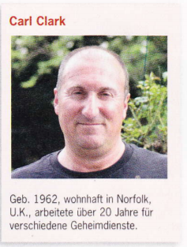

Carl Clark: It’s a bit like what takes place in a science fiction movie. People can be tracked anywhere by radar, satellite, a base station and complimentary computer programs. For example, three radar devices would sometimes be positioned in the vicinity of the target. The radar emits electromagnetic waves, some of which pick up the target and the result is then evaluated. My friends who work in the special department could then follow the target all day on their computers. This form of localising the target made it easy to deploy the weapons accurately. My colleagues could see exactly where to aim and also observe how the target reacted.
[Note he left this work in the early 2000s, when it was still somewhat more manual and individual based rather then computational]

Carl Clark: There are about 5,000 in England under surveillance and about 15,000 overseeing the operation. Apart from the large Secret Service agencies, there are 300 or 400 minor Secret Service agencies which were formed by former policemen or former Secret Service agents. They have permission from the Home Office to spy, take photographs and procure information. Their employees are well paid.
https://www.stopeg.com/doc/CarlClarkInterview.pdf (accessed 4/3/19)

[Mention Nozawa worked on Radar systems]

Norseen on comparing holography to radar:

couple emails back you talked about how you can feel different thought patterns, sometimes just a twinge, other times full bore…well, I wrote a rather lengthy project report for NASA back in 2000 and also for NSA related to Cryptomnesia…this is Greek for the Continuum of signals and noises that can occur in a brain.
Imagine a Vertical Bar to the left of this page. In the middle of the bar would be zero dB or decibel, and it would move to over 100 db + positive to the top...and in the same vein would register down into 150-200 db – negative.
This is exactly the same kind of measurement scale that is used to rate a submarine sound signal or Electromagnetic Signal...positive and negative. Well, it is possible using EEG and other BioFusion tools that one can track the movement of Identified Thoughts or Semiotic Structures as they emanate Functions or Communications (INTENT). In fact, right now, you Duncan, probably have hundreds or thousands of Thoughts and mini-thoughts that are dancing around, and banging around inside your head, just like a radar sweep looking out at weather patterns…one can radar sweep the semiotic conditions inside of your head and plot them on this Cryptomnesia Scale. You can even apply Doppler analysis and see which thoughts are growing in intensity, or dying out, or getting stuck in “feed-back” loops, sustaining themselves, perhaps in Unconscious or Non-Cognitive zones, at let's say – 100 db or -35-50 db, self obsessive routines, etc. etc.
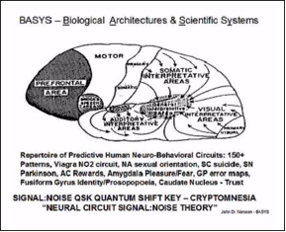
FIGURE 30: BASYS, BIOLOGICAL ARCHITECTURES & SCIENTIFIC SYSTEMS
When thoughts emerge past zero and move into the high positive values then you can clearly see that that is what is occupying the Mental Awake State of the person...you can flash brief visuals or sound types or kinesthetic potentials, and you can see the Brain Thought adjust…
Well, equally, if you are aware that a person is entering an Alpha State, or better yet, a hypnogogic (falling asleep) or a hypnopompic state (pre-waking state) of an modified Theta-Alpha brain engagement region...you can actually see the subconscious mind at work and interact with it...you can actually Inject Semiotics into the mental region and see the Brain Thoughts surround the Semiotic, infuse it, and then act upon it right into the Awake States. In this way, you can DIE INJECT, action potentials...for influencing someone during the day...or you can do the same thing and get Alert Semiotics injected into the sleeping and even into the LIFE-Death interface of the Delta state...you can probe the deepest depths of the person and see just exactly how deep into the abyss, the db, you can go...You can even affect someone with Semiotic cues down at negative (-) 200 db…down at the very bottom of our semiotic ability to understand information, and right at the zone where Alfven Wave corridors of the brain Magnetite exchange ZPE in the dendritic neuropil at nanoscale, discrete bandwidth, channels. It is right here in the Marianas Trench of human thought/perception, that the person is exposed to the Universals of Quantum State potentials, and that each individual thought or Semiotic Identity is formed, only to then bubble or shoot right up to the surface of positive thought realms.
Just as you can look into an aquarium or a fish bowl and see the stuff at the bottom work its way up to the surface, you can track the origin of Semiotics from Alfven Wave Interactions with ZPE, from the plumbed depths of the Brain.
(Norseen, 2002, part 6)

--------------------------------
NSA using radar to energize targets:

[CTX4000: Continuous wave radar device that can ""illuminate" a target system for recovery of "off net" information.[22]

]

[NIGHTWATCH: Portable computer used to reconstruct and display video data from VAGRANT signals; used in conjunction with a radar source like the CTX4000 to illuminate the target in order to receive data from it.
https://en.wikipedia.org/wiki/NSA_ANT_catalog]
[PHOTOANGLO: A joint NSA/GCHQ project to develop a radar system to replace CTX4000.[22]
]
[See Note on Radar in Notes directory]
The TAO has developed an attack suite they call QUANTUM. It relies on a compromised router that duplicates internet traffic, typically HTTP requests, so that they go both to the intended target and to an NSA site (indirectly). The NSA site runs FOXACID software which sends back exploits that load in the background in the target web browser before the intended destination has had a chance to respond (it's unclear if the compromised router facilitates this race on the return trip). Prior to the development of this technology, FOXACID software made spear-phishing attacks the NSA referred to as spam. If the browser is exploitable, further permanent "implants" (rootkits etc.) are deployed in the target computer, e.g. OLYMPUSFIRE for Windows, which give complete remote access to the infected machine.[18] This type of attack is part of the man-in-the-middle attack family, though more specifically it is called man-on-the-side attack. It is difficult to pull off without controlling some of the Internet backbone.[19]
There are numerous servic
https://en.wikipedia.org/wiki/Tailored_Access_Operations

By collaboration with the British Government Communications Headquarters (GCHQ) (MUSCULAR), Google services could be attacked too, including Gmail.[21]
Finding machines that are exploitable and worth attacking is done using analytic databases such as XKeyscore.[22] A specific method of finding vulnerable machines is interception of Windows Error Reporting traffic, which is logged into XKeyscore.[23]
QUANTUM attacks launched from NSA sites can be too slow for some combinations of targets and services as they essentially try to exploit a race condition, i.e. the NSA server is trying to beat the legitimate server with its response.[24] As of mid-2011, the NSA was prototyping a capability codenamed QFIRE, which involved embedding their exploit-dispensing servers in virtual machines (running on VMware ESX) hosted closer to the target, in the so-called Special Collection Sites (SCS) network worldwide. The goal of QFIRE was to lower the latency of the spoofed response, thus increasing the probability of success.[25][26][27]
COMMENDEER [sic] is used to commandeer (i.e. compromise) untargeted computer systems. The software is used as a part of QUANTUMNATION, which also includes the software vulnerability scanner VALIDATOR. The tool was first described at the 2014 Chaos Communication Congress by Jacob Appelbaum, who characterized it as tyrannical.[28][29][30]
QUANTUMCOOKIE is a more complex form of attack which can be used against Tor users.[31]

- TAO's QUANTUM INSERT technology was passed to UK services, particularly to GCHQ's MyNOC, which used it to target Belgacom and GPRS roaming exchange (GRX) providers like the Comfone, Syniverse, and Starhome.[23] Belgacom, which provides services to the European Commission, the European Parliament and the European Council discovered the attack.[34]

------------------------------------

Time Reversed Radar: pg. 285

Bearden, Thomas ‘Excalibur bzriefing: Understanding Paranormal Phenomena’ 1988

At the end of WWII, the Soviet Union obtained the cream of the crop of Germany's radar scientists and infrared scientists.
At that time, the German scientific team led the world in the theory and technology of radar absorbing materials (RAM) and radar cross section. For example, some leading Western radar experts believe that the German scientists had already advanced the theory of radar cross section beyond where Western scientists have arrived at today. Radar cross section science is the "heart" of modern radar technology, countermeasures, and counter-countermeasures.
The theory of RAM technology is precisely what is needed to develop and design phase conjugate mirrors for radar frequency bands. Phase conjugate mirrors are capable of producing a time-reversed (TR) wave in direct response to a received ordinary wave. The mirror may be powerfully "pumped" with energy to produce a very large amplification of the time-reversed wave.

He continues:

Compared to a normal wave, a time-reversed wave has startlingly different weapon capabilities.
Such a wave precisely retraces the path of the ordinary wave that stimulated it to be formed. So it possesses an "invisible wire" through space, back to the original position of whatever emitted its stimulus wave.
Further, the time-reversed wave continually converges upon its invisible "back- tracking" path. It does not diverge and spread its energy, in contradistinction to normal waves.
Using several simple schemes (particularly pumped 4-wave mixing), extremely large amplification of the time-reversed (TR) wave can be cheaply and readily accomplished.
A startling weapons capability therefore emerges when amplified TR waves are generated in response to received signals from a distant target:
(1) If any signal at all can be received from a distant target, a return TR signal of extreme power can be delivered directly to that target Almost all of the transmitted TR signal energy will arrive at and in the distant target, even through a highly nonlinear medium or under scattering conditions. Hardly any of the energy will be lost enroute. If the target is fast-moving, a "lead correction" signal can be calculated and added to steer the return path.
(2) Since real-time holography can readily be accomplished using TR waves - and without first making holograms, geometrical forms (balls, shapes, hemispherical shells, etc) of energy can be created readily by interferometry (crossed beam techniques). Since the TR wave carriers do not disperse with distance, these interference energy forms can be assembled by crossed TR wave beams at great distances-even hundreds of thousands of miles. The energy appearing in such a distantly created energy form is limited only by the amount one cares to put in at the amplified transmitting end.
Thus the radar itself now becomes a powerful, all-around weapon. With a TR wave adjunct, once the radar receives a return signal from a target, an extremely powerful TR wave pulse can be generated, and all the energy in that pulse can be unerringly returned to the distant target from which the return was received.

Eyes as Radar
start section with Pavlita example using eyes to transfer em to cavity resonator, take a screenshot of the film.

definitions:
fractal antenna- electronic conduction and self-symmetry as in DNA

“Mainly the Fibonacci Sequence-based structure or the periodical array of basic phyisological units (such as phtoreceptors within the retina) is responsible for optimizing the signal communication in biological living systems” in ‘Fractal and Periodical Biological Antennas, Hidden Topologies in DNA, Wasps and Retina in the Eye’ (2018) Bandy group

also see ‘Biological Infrared Antenna and Radar’ (2019)

---------
Singh et al. ‘DNA as an Electromagnetic Fractal Cavity Resonators Its Universal Sensing and Fractal Antenna Behavior’ (2018).
“We report that 3d-A-DNA structure behaves as a fractal antenna, which can interact with EM fields [and of course gravitational fields] over a wide range of frequencies. Using the lattice details of human DNA, we have modeled induction of DNA as a helical antenna. The DNA structure resonates with the EM waves at 34Ghz, with a positive gain of 1.7dBi.” (Singh, 2018)

Originally based on proposal in 2011, but can argued to originate with Kazhinsky in 1920s, ‘DNA is a fractal Antenna in electromagnetic fields’ M. Blank, R. Goodman International Journal of Radiation Biology Vol. 87, 2011 Issue 4

the greater reactivity of DNA with EMF the higher the chance of cancer [adverse mutation or mutation in general]

-----------------------

Singh et al. ‘Frequency Fractal Behavior in the Retina Nano-Center-Fed Dipole Antenna Network of a Human Eye’ (2018),
“It has been argued that thte proteins vibrate in the presence of electromagnetic signal like a cavity resonator….Protein synthesis is stimulated by electromagnetic fields of the specific frequency in the RF range….Since we now have evidence that proteins vibrate electromagneitcally, we can revisit the electromagneitc interaction in the cells, considering the whole cell as a cavity resonator.” pg. 3
[microwave cavity resonators are used to detect HFGW]
‘Microwave cavity gravitational radiation detectors’ Carlton M. Caves Physics Letters B Vol. 80, Issue 3, (1979) pages 323-6 Abstract: “The coupled electro-mechanical system consisting of a microwave cavity and its walls can serve as a gravitational radiation detector. A gravitational wave interactes with the walls, and the resulting motion induces transitions from a highly excited cavity mode to a neraly unexcited mode.”
[is this also true of klystron, wouldn’t any early Radar system also be a gravitational radiation detector as early as Radar existed? ]

eyes retina nano-center is a dipole antenna network.
“If a rotation of the ight wave underlies the laser emission then the possibility of helical electron transmission increases” pg. 9
“the network of cells acts as an array of helical antennas.” pg. 9
Octagonal [so GW is Quaternion, Bandy. Writes about Octo some shit in Artificial Brain, EHT uses octo some shit two, so whats up with this repeating fractal pattern at various scales?]
“Octagonal order in rods and cones (photoreceptors)”
3 types of cones, s, m, l wavelengths trichromatic(r,g,b); r=400nm, g=550nm, b=700nm
[does green manipulate red and blue?????!!!!]

[would there be any trace if you alter RNA process rather then change the permanent record of the DNA? RNA gets thrown out. ]
---------------------------------------------

